**SQL Project**

( Tour And Travel Management System) 



- Abhishek More

* **Summary :-**

Find Your Next Fun Adventure with **Travel-Trove**.

At **Travel-Trove**, we help you find awesome places to visit and exciting things to do. Whether

you want to see new cities, or relax on a sunny beach, we have the perfect trip for you.

* **Why Pick Us :-**

1. **Great Deals :** Save money with our awesome offers.
2. **Easy Booking :** Book your trip online with help whenever you need it.
3. **Better Adventures :** We’re making our trips more exciting with new things to do.
4. **More Fun Places :** We want to find even more cool places for you to visit.

**ER diagram & Normalization.**

* **ER-diagram ( Entity-** **Relationship Diagram ) :**

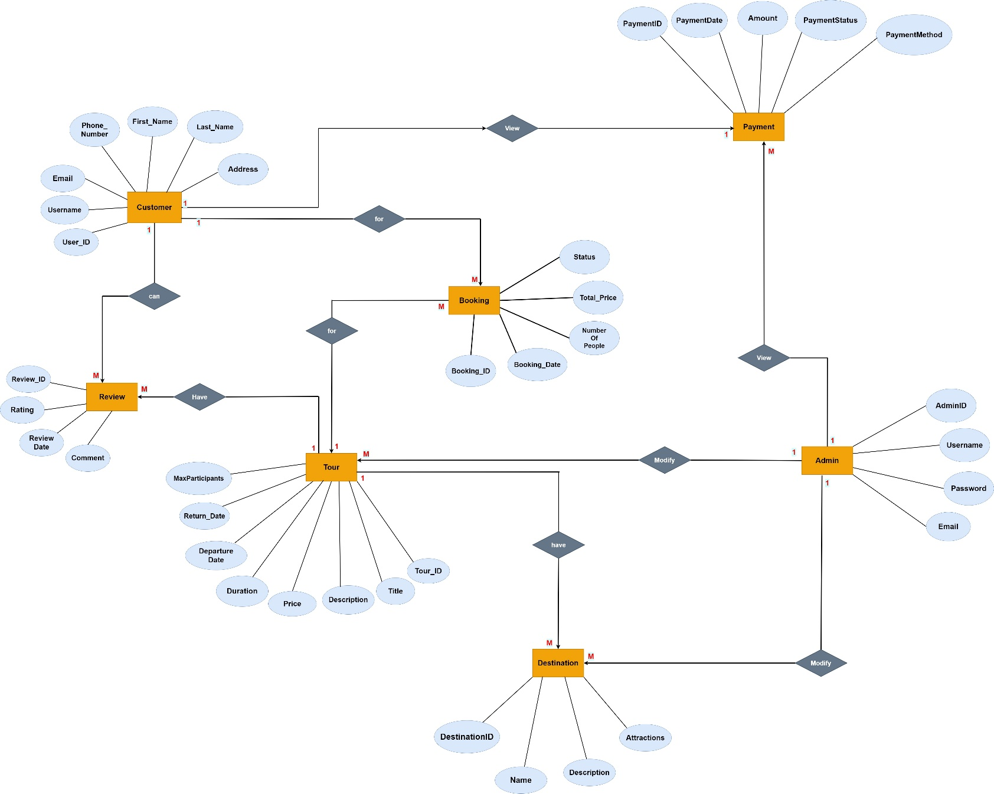

* **Normalization :**

Normalization in SQL is the process of organizing a database's tables and columns to minimize data redundancy and improve data integrity.

**(1NF)**

|  |  |  |  |  |  |  |  |  |  |
| --- | --- | --- | --- | --- | --- | --- | --- | --- | --- |
| **User_Name** | **Email** | **Phone_No** | **first_Name** | **Address** | **Booking_Date** | **No_Of_People** | **Total_Price** | **Tour_Title** | **Tour_Description** |
|  |  |  |  |  |  |  |  |  |  |
| RaviKumar21 | ravi.kumar@example.com | 9876543210 | Ravi | 123, Ashoka Avenue, Delhi | 16/6/2024 | 2 | 20,800 | Himalayan Escape | Experience the serene beauty of the Himalayas with scenic treks and cultural immersion. |
| SharmaAnanya09 | ananya.sharma@example.com | 9876543141 | Ananya | 456, Jasmine Street, Mumbai | 22/7/2024 | 4 | 67,000 | Royal Rajasthan Tour | Explore the grandeur of Rajasthan with visits to majestic forts, palaces, and vibrant markets. |
| RajPatel2001 | raj.patel@example.com | 9876543872 | Raj | 789, Maple Road, Bangalore | 12/10/2024 | 3 | 33,200 | South Indian Getaway | Discover the rich cultural heritage and lush landscapes of South India with guided tours and local cuisine. |
| MeeraG1999 | meera.gupta@example.com | 9876543961 | Meera | 101, Rose Park, Kolkata | 9/5/2024 | 1 | 49,000 | Coastal Adventure | Visit India's iconic landmarks: Delhi, Agra, and Jaipur, with historical sites and luxury stays. |
| SinghArjun1995 | arjun.singh@example.com | 9876543832 | Arjun | 202, Orchid Lane, Chennai | 2/3/2024 | 5 | 87,000 | Golden Triangle Tour | Enjoy a relaxing coastal trip with beachside resorts, water sports, and vibrant coastal culture. |

**Continue Table**



|  |  |  |  |  |  |  |  |  |  |
| --- | --- | --- | --- | --- | --- | --- | --- | --- | --- |
| **Tour_Price** | **Tour_Duration** | **Departure_Time** | **Return_Time** | **Maximum_People** | **Destination_Name** | **Destination_Description** | **Destination_attractions** | **Rating** | **Review_Date** |
|  |  |  |  |  |  |  |  |  |  |
| 1200 | 7 | 8:00 AM | 22/6/2024 | 18 | Shimla | Shimla: Known for its lush green hills and cool climate. | Shimla: Mall Road, Jakhoo Temple. | 4.8 | 15/7/2024 |
| 1500 | 10 | 9:30 AM | 28/7/2024 | 20 | Jaipur | Jaipur: The Pink City, known for its palaces and forts. | Jaipur: Amer Fort, Hawa Mahal. | 4.7 | 14/8/2024 |
| 2500 | 14 | 7:45 AM | 20/10/2024 | 19 | Kerala, Tamil Nadu | Kerala: Known for its backwaters and beaches. | Kerala: Backwaters, Munnar Tea Gardens. | 4.6 | 2/11/2024 |
| 4000 | 8 | 10:00 AM | 15/5/2024 | 21 | Delhi, Agra, Jaipur | Agra: Home to the Taj Mahal. | Agra: Taj Mahal, Agra Fort. | 4.9 | 22/7/2024 |
| 4000 | 12 | 6:30 AM | 10/3/2024 | 17 | Goa, Kerala | Goa: Famous for its beaches, nightlife, and Portuguese heritage. | Goa: Baga Beach, Fort Aguada. Kerala: Alleppey Backwaters, Kovalam Beach. | 4.5 | 20/5/2024 |

**Continue Table**



|  |  |  |  |  |  |  |
| --- | --- | --- | --- | --- | --- | --- |
| **Review_Comment** | **Payment_Date** | **Payment_Amount** | **Payment_Status** | **Payment_Method** | **Admin_Username** | **Admin_Email** |
|  |  |  |  |  |  |  |
| "Amazing experience! The views were breathtaking and the guides were very knowledgeable." | 17/6/2024 | 22,000 | Paid | Credit Card | AbhiMore22 | [abhishekmore504@gmail.com](mailto:abhishekmore504@gmail.com) |
| "The tour was fantastic, but we wished there were more time to explore Udaipur." | 23/7/2024 | 69,000 | Pending | UPI | AbhiMore22 | [abhishekmore504@gmail.com](mailto:abhishekmore504@gmail.com) |
| "Incredible trip with a perfect mix of relaxation and exploration. Highly recommend!" | 13/10/2024 | 35,200 | Paid | Credit Card | AbhiMore22 | [abhishekmore504@gmail.com](mailto:abhishekmore504@gmail.com) |
| "An unforgettable experience! Every site was more impressive than the last. A must-do tour!" | 10/5/2024 | 51,000 | Paid | Debit Card | AbhiMore22 | [abhishekmore504@gmail.com](mailto:abhishekmore504@gmail.com) |
| "The beaches were beautiful and the resorts were top-notch. Perfect for a beach getaway!" | 3/3/2024 | 89,000 | Paid | Credit Card | AbhiMore22 | [abhishekmore504@gmail.com](mailto:abhishekmore504@gmail.com) |

**(2NF)**

|  |  |  |  |  |  |  |  |  |  |
| --- | --- | --- | --- | --- | --- | --- | --- | --- | --- |
| **User_Name** | **Email** | **Phone_No** | **first_Name** | **Address** | **Booking_Date** | **No_Of_People** | **Total_Price** | **Tour_Title** | **Tour_Description** |
|  |  |  |  |  |  |  |  |  |  |
| RaviKumar21 | ravi.kumar@example.com | 9876543210 | Ravi | 123, Ashoka Avenue, Delhi | 16/6/2024 | 2 | 20,800 | Himalayan Escape | Experience the serene beauty of the Himalayas with scenic treks and cultural immersion. |
| SharmaAnanya09 | ananya.sharma@example.com | 9876543141 | Ananya | 456, Jasmine Street, Mumbai | 22/7/2024 | 4 | 67,000 | Royal Rajasthan Tour | Explore the grandeur of Rajasthan with visits to majestic forts, palaces, and vibrant markets. |
| RajPatel2001 | raj.patel@example.com | 9876543872 | Raj | 789, Maple Road, Bangalore | 12/10/2024 | 3 | 33,200 | South Indian Getaway | Discover the rich cultural heritage and lush landscapes of South India with guided tours and local cuisine. |
| MeeraG1999 | meera.gupta@example.com | 9876543961 | Meera | 101, Rose Park, Kolkata | 9/5/2024 | 1 | 49,000 | Coastal Adventure | Visit India's iconic landmarks: Delhi, Agra, and Jaipur, with historical sites and luxury stays. |
| SinghArjun1995 | arjun.singh@example.com | 9876543832 | Arjun | 202, Orchid Lane, Chennai | 2/3/2024 | 5 | 87,000 | Golden Triangle Tour | Enjoy a relaxing coastal trip with beachside resorts, water sports, and vibrant coastal culture. |

**Continue Table**



|  |  |  |  |  |  |  |  |  |  |
| --- | --- | --- | --- | --- | --- | --- | --- | --- | --- |
| **Tour_Price** | **Tour_Duration** | **Departure_Time** | **Return_Time** | **Maximum_People** | **Destination_Name** | **Destination_Description** | **Destination_attractions** | **Rating** | **Review_Date** |
|  |  |  |  |  |  |  |  |  |  |
| 1200 | 7 | 8:00 AM | 22/6/2024 | 18 | Shimla | Shimla: Known for its lush green hills and cool climate. | Shimla: Mall Road, Jakhoo Temple. | 4.8 | 15/7/2024 |
| 1500 | 10 | 9:30 AM | 28/7/2024 | 20 | Jaipur | Jaipur: The Pink City, known for its palaces and forts. | Jaipur: Amer Fort, Hawa Mahal. | 4.7 | 14/8/2024 |
| 2500 | 14 | 7:45 AM | 20/10/2024 | 19 | Kerala, Tamil Nadu | Kerala: Known for its backwaters and beaches. | Kerala: Backwaters, Munnar Tea Gardens. | 4.6 | 2/11/2024 |
| 4000 | 8 | 10:00 AM | 15/5/2024 | 21 | Delhi, Agra, Jaipur | Agra: Home to the Taj Mahal. | Agra: Taj Mahal, Agra Fort. | 4.9 | 22/7/2024 |
| 4000 | 12 | 6:30 AM | 10/3/2024 | 17 | Goa, Kerala | Goa: Famous for its beaches, nightlife, and Portuguese heritage. | Goa: Baga Beach, Fort Aguada. Kerala: Alleppey Backwaters, Kovalam Beach. | 4.5 | 20/5/2024 |

**Continue Table**



|  |  |  |  |  |  |  |
| --- | --- | --- | --- | --- | --- | --- |
| **Review_Coment** | **Payment_Date** | **Payment_Amount** | **Payment_Status** | **Payment_Method** | **Admin_Username** | **Admin_Email** |
|  |  |  |  |  |  |  |
| "Amazing experience! The views were breathtaking and the guides were very knowledgeable." | 17/6/2024 | 22,000 | Paid | Credit Card | AbhiMore22 | [abhishekmore504@gmail.com](mailto:abhishekmore504@gmail.com) |
| "The tour was fantastic, but we wished there were more time to explore Udaipur." | 23/7/2024 | 69,000 | Pending | UPI | AbhiMore22 | [abhishekmore504@gmail.com](mailto:abhishekmore504@gmail.com) |
| "Incredible trip with a perfect mix of relaxation and exploration. Highly recommend!" | 13/10/2024 | 35,200 | Paid | Credit Card | AbhiMore22 | [abhishekmore504@gmail.com](mailto:abhishekmore504@gmail.com) |
| "An unforgettable experience! Every site was more impressive than the last. A must-do tour!" | 05-10-2024 | 51,000 | Paid | Debit Card | AbhiMore22 | [abhishekmore504@gmail.com](mailto:abhishekmore504@gmail.com) |
| "The beaches were beautiful and the resorts were top-notch. Perfect for a beach getaway!" | 03-03-2024 | 89,000 | Paid | Credit Card | AbhiMore22 | [abhishekmore504@gmail.com](mailto:abhishekmore504@gmail.com) |

**3NF**

**#User Table**

|  |  |  |  |  |  |
| --- | --- | --- | --- | --- | --- |
| **User_ID ( PK )** | **Username** | **Email** | **Phone_No** | **Last_Name** | **Address** |
|  |  |  |  |  |  |
| 1 | RaviKumar21 | ravi.kumar@example.com | 9876543210 | Kumar | 123, Ashoka Avenue, Delhi |
| 2 | SharmaAnanya09 | ananya.sharma@example.com | 9876543141 | Sharma | 456, Jasmine Street, Mumbai |
| 3 | RajPatel2001 | raj.patel@example.com | 9876543872 | Patel | 789, Maple Road, Bangalore |
| 4 | MeeraG1999 | meera.gupta@example.com | 9876543961 | Gupta | 101, Rose Park, Kolkata |
| 5 | SinghArjun1995 | arjun.singh@example.com | 9876543832 | Singh | 202, Orchid Lane, Chennai |

#Booking Table

|  |  |  |  |  |  |
| --- | --- | --- | --- | --- | --- |
| **Booking_ID (PK)** | **Booking_Date** | **No_Of_People** | **Total_Price** | **Tour_ID ( FK)** | **User_ID ( FK )** |
|  |  |  |  |  |  |
| 101 | 16/6/2024 | 2 | 20,800 | 201 | 1 |
| 102 | 22/7/2024 | 4 | 67,000 | 202 | 2 |
| 103 | 10-12-2024 | 3 | 33,200 | 203 | 3 |
| 104 | 05-09-2024 | 1 | 49,000 | 204 | 4 |
| 105 | 03-02-2024 | 5 | 87,000 | 205 | 5 |

#Destination Table

|  |  |  |  |
| --- | --- | --- | --- |
| **Destination_ID (PK)** | **Destination_Name** | **Destination_Description** | **Destination_attractions** |
|  |  |  |  |
| 301 | Shimla | Shimla: Known for its lush green hills and cool climate. | Shimla: Mall Road, Jakhoo Temple. |
| 302 | Jaipur | Jaipur: The Pink City, known for its palaces and forts. | Jaipur: Amer Fort, Hawa Mahal. |
| 303 | Kerala | Kerala: Known for its backwaters and beaches. | Kerala: Backwaters, Munnar Tea Gardens. |
| 304 | Agra | Agra: Home to the Taj Mahal. | Agra: Taj Mahal, Agra Fort. |
| 305 | Goa | Goa: Famous for its beaches, nightlife, and Portuguese heritage. | Goa: Baga Beach, Fort Aguada. |

**#Tour Table**

|  |  |  |  |  |  |  |  |
| --- | --- | --- | --- | --- | --- | --- | --- |
| **Tour_ID ( PK)** | **Tour_Title** | **Tour_Description** | **Tour_Price** | **Departure_Time** | **Return_Time** | **Maximum_People** | **Destination_ID (PK)** |
|  |  |  |  |  |  |  |  |
| 201 | Himalayan Escape | Experience the serene beauty of the Himalayas with scenic treks and cultural immersion. | 1200 | 8:00 AM | 22/6/2024 | 18 | 301 |
| 202 | Royal Rajasthan Tour | Explore the grandeur of Rajasthan with visits to majestic forts, palaces, and vibrant markets. | 1500 | 9:30 AM | 28/7/2024 | 20 | 302 |
| 203 | South Indian Getaway | Discover the rich cultural heritage and lush landscapes of South India with guided tours and local cuisine. | 2500 | 7:45 AM | 20/10/2024 | 19 | 303 |
| 204 | Coastal Adventure | Visit India's iconic landmarks: Delhi, Agra, and Jaipur, with historical sites and luxury stays. | 4000 | 10:00 AM | 15/5/2024 | 21 | 304 |
| 205 | Golden Triangle Tour | Enjoy a relaxing coastal trip with beachside resorts, water sports, and vibrant coastal culture. | 4000 | 6:30 AM | 03-10-2024 | 17 | 305 |

#Rating Table

|  |  |  |  |  |  |
| --- | --- | --- | --- | --- | --- |
| **Rating_ID ( PK )** | **Rating** | **Review_Date** | **Review_Coment** | **Tour_ID ( PK)** | **User_ID ( PK )** |
|  |  |  |  |  |  |
| 401 | 4.8 | 15/7/2024 | "Amazing experience! The views were breathtaking and the guides were very knowledgeable." | 201 | 1 |
| 402 | 4.7 | 14/8/2024 | "The tour was fantastic, but we wished there were more time to explore Udaipur." | 202 | 2 |
| 403 | 4.6 | 11-02-2024 | "Incredible trip with a perfect mix of relaxation and exploration. Highly recommend!" | 203 | 3 |
| 404 | 4.9 | 22/7/2024 | "An unforgettable experience! Every site was more impressive than the last. A must-do tour!" | 204 | 4 |
| 405 | 4.5 | 20/5/2024 | "The beaches were beautiful and the resorts were top-notch. Perfect for a beach getaway!" | 205 | 5 |

#Payment Table

|  |  |  |  |  |
| --- | --- | --- | --- | --- |
| **Payment_ID ( PK )** | **Payment_Date** | **Payment_Amount** | **Payment_Status** | **Booking_ID (PK)** |
|  |  |  |  |  |
| 501 | 17/6/2024 | 22,000 | Paid | 101 |
| 502 | 23/7/2024 | 69,000 | Pending | 102 |
| 503 | 13/10/2024 | 35,200 | Paid | 103 |
| 504 | 05-10-2024 | 51,000 | Paid | 104 |
| 505 | 03-03-2024 | 89,000 | Paid | 105 |

#Admin Table

|  |  |  |
| --- | --- | --- |
| **Admin_ID ( PK )** | **Admin_Username** | **Admin_Email** |
|  |  |  |
| **501** | AbhiMore22 | [abhishekmore504@gmail.com](mailto:abhishekmore504@gmail.com) |

**SQL command**

* **DDL ( Data Definition Language )**

**Data Definition Language is used to Define the structure of the Database.**

**DDL Commands :-**

1. **Create**
2. **Alter**
3. **Rename**
4. **Drop**
5. **Truncate**

* **Create Databases :**



* **Use database :**



* **Create table :**

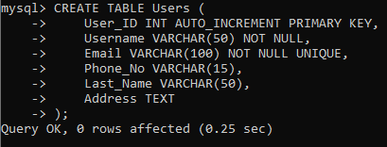

* **Show tables:**

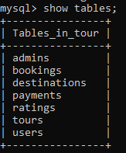

* **Desc tables:**

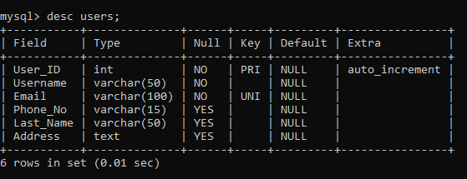

* **Alter Commands.**

**Alter is Used to update the structure of the table in the database.**

1. **ADD CONSTRAINT using alter commands:**



**Output:-**

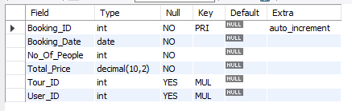

1. **Rename column Name using alter commands:**



**Output:-**

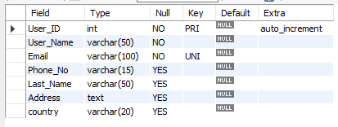

1. **Add column Specific location using alter commands:**



**Output:-**



* **Truncate Table and Drop table**

1. **Drop Table :-**

The DROP TABLE statement is used to drop an existing table in a database.



**Output :-**

Before :- After :-

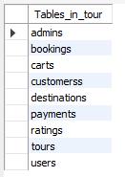 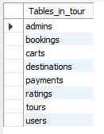

1. **Truncate Table :-**

The TRUNCATE TABLE statement is used to delete the data inside a table.



**Output :-**

Before :- After :-

 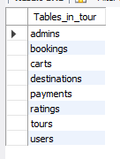

DML

( Data Manipulation Language )

* This language commands are used to change or manipulate data in database tables.
* DML commands :-

1. Insert.
2. Update.
3. Delete.

**Insert values in table in multiple Ways :-**

1. **First way** :-

Insert single Values in tables.



**Output :-**



1. **Second way** :- Insert multiple values in tables.

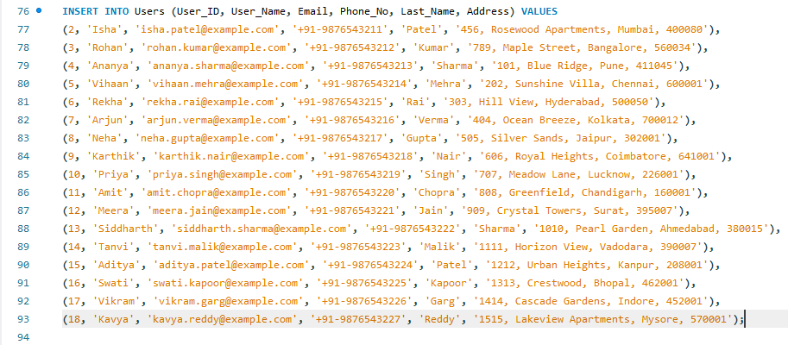

**Output :-**

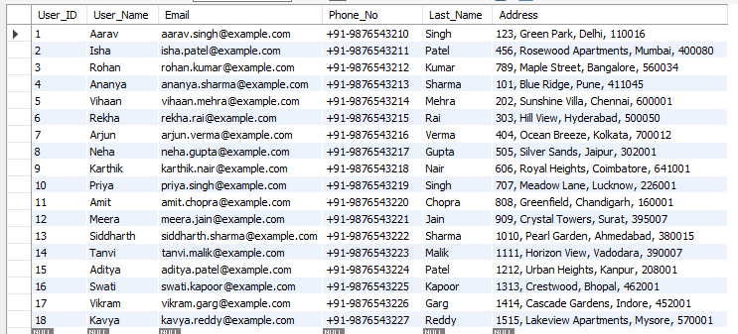

1. **Third ways :-**

Insert single values with column Name.



**Output :-**

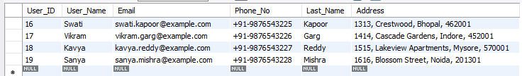

Update Query :-

1. Update single values using Where conditions :-

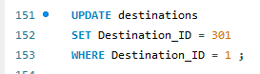

**Output :-**

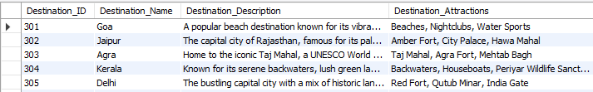

1. **Update all data in single query :-**



**Output :-**

Before After

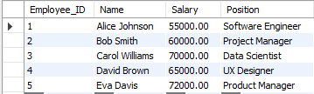 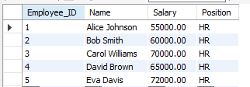

**Delete :-**

1. delete one row :



**Output :-**

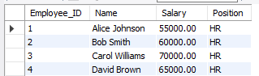

1. delete Multiple Rows :-



**Output:-**

Before After

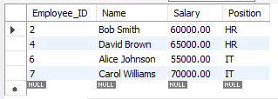 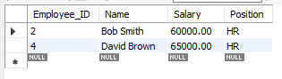

1. delete all records :-



Before After

 

DQL

( Data Query Language )

**SELECT** command is used to fetch data from one or more tables in a database.

**Select :-**

1. Select all date single Query :-



**Output :-**

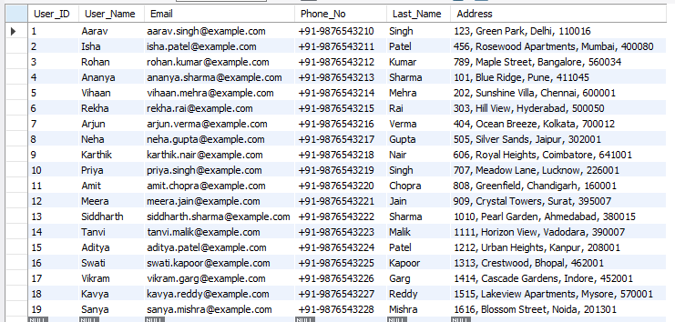

1. **Select Specific column single Query :-**



**Output :-**

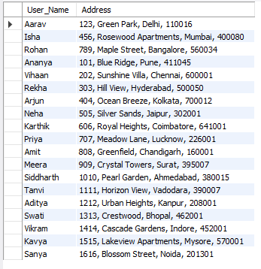

1. Select query using distinct :-



**Output :-**

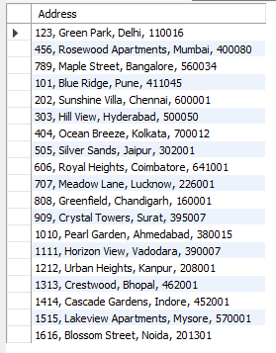

**Where & Where AND**

Select query using where condition :-



Output :-

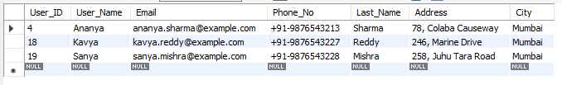

**Select query using where AND condition**



**Output :-**

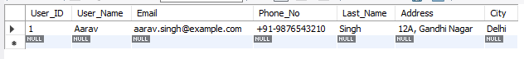

**Range**

1. **Between :-**



**Output :-**

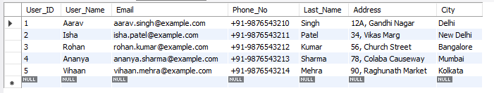

1. **Not-Between :-**



**Output :-**

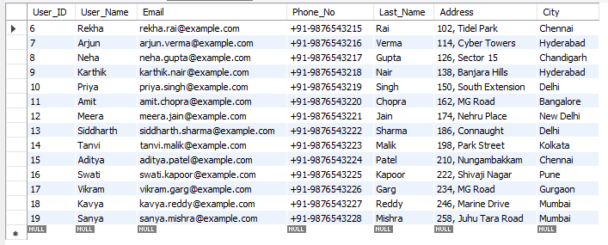

**LIST Operator**

1. **In :-**



**Output :-**

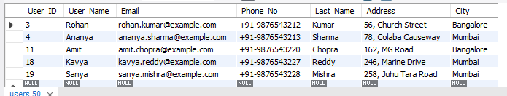

1. **Not-IN :-**



**Output :-**

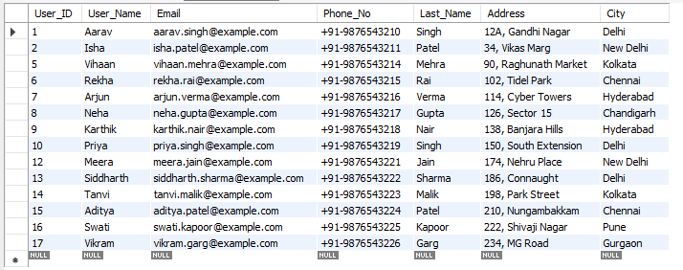

**Like Operator**

1. **% symbol use to find single letter.**



**Output :-**

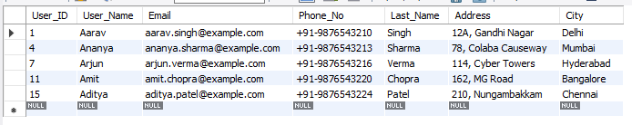

1. **_ to find end with letter in data.**



**Output :-**

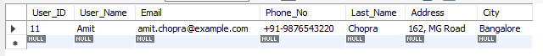

1. **Find letter to any location :-**



**Output :-**

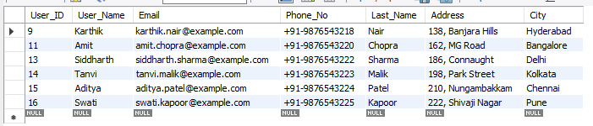

**Order operators**

1. **Display data in ascending :-**



**Output :-**

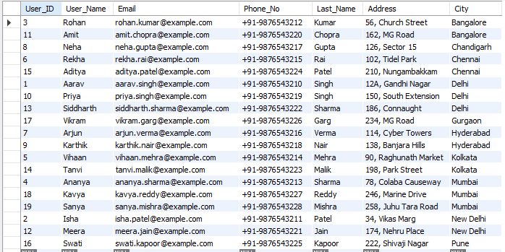

1. **Display data in descending :-**



**Output :-**

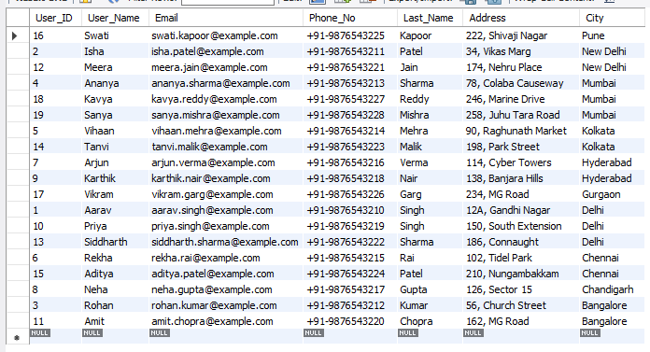

**Limit operators**

**limit operators are used to control the number of rows returned by a query.**



**Output :-**

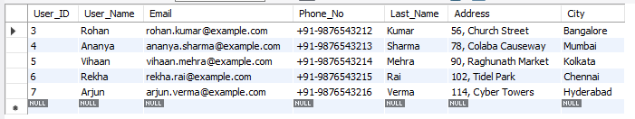

**CASE STATEMENT**

The **CASE** statement in SQL is used to perform conditional logic in queries.

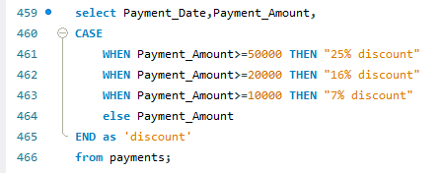

**Output :-**

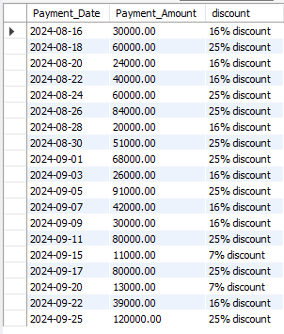

**Aggregate Function**

Aggregate means summarizing a group of rows into a single value.

1. **Find minimun payment :-**



**Output :-**



1. Find maximum payment :-



Output :-



1. Find Average of payment :-



Output :-



1. Calculate Count number in table.



**Output :-**



1. To find total calculate amount :-



Output :-



**Comparison Operator**

1. **Equal to :-**



**Output :-**

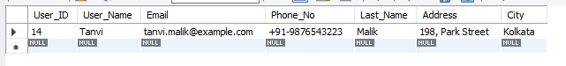

1. **Not Equal To First Way:-**



**Output :-**

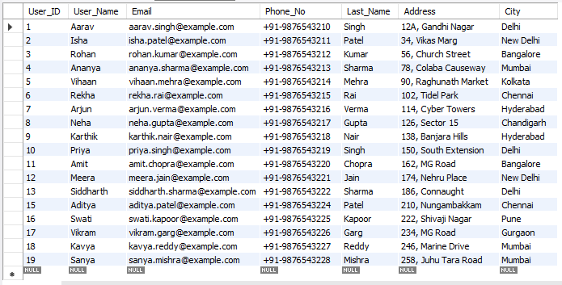

1. **Not Equal To Second Way:-**



Output :-



1. Greater than :-



Output :-

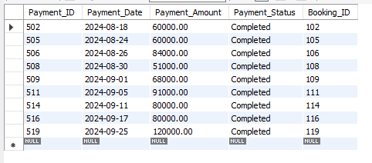

1. Less than :-



Output :-

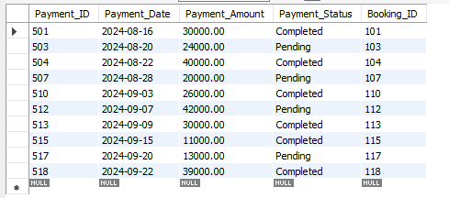

1. Greater Than equal to :-



Output :

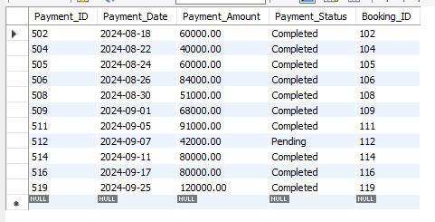

1. Less than equal to :-



Output :-

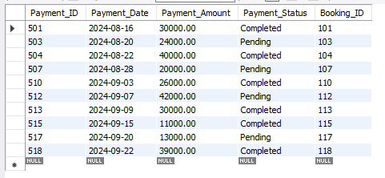

**String function**

1. **Concat funcation :-**

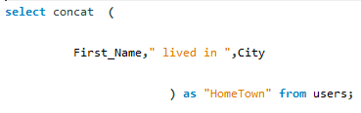

**Output :-**

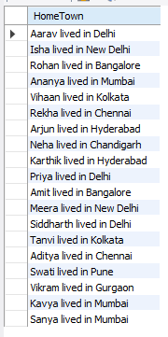

1. **Upper funcation :-**



**Output :-**

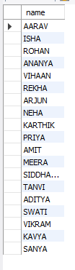

1. **Lower funcation :-**



**Output :-**

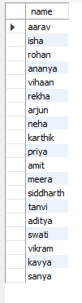

1. **Length funaction :-**



**Output :-**

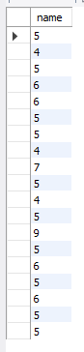

1. **char_length :-**



**Output :-**

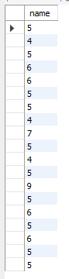

1. **sup-string :-**



**Output :-**

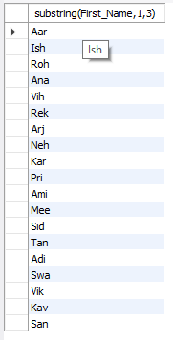

1. **reverse**



**Output :-**

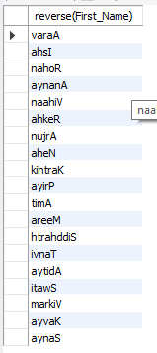

**Date**

1. **To show current date :-**



**Output :-**



1. **Second Ways**



**Output :-**

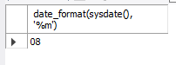

**Group By**

**GROUP BY is a clause used to group rows that have the same values in specified columns into summary rows.**



**Output :-**

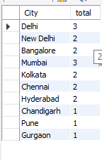

**Having Clause**

The **HAVING** clause in SQL is used to filter the results of a query based on aggregate function results.



Output :-

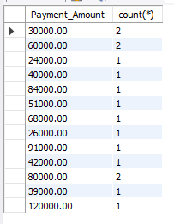

**Sub-Query**

**Subqueries can be used to perform operations that require results from another query.**

1. Single row sub-query.



Output :-

**Output:**

1. **Multiple row subquery :-**
2. **IN :-**



**Output :-**

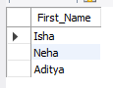

1. **ANY :-**



**Output :-**

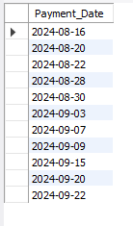

1. **ALL :-**



**Output :-**

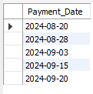

**Joins**

joins are used to combine rows from two or more tables based on a related column between them.

1. **Cross Joins :-**



**Output :-**

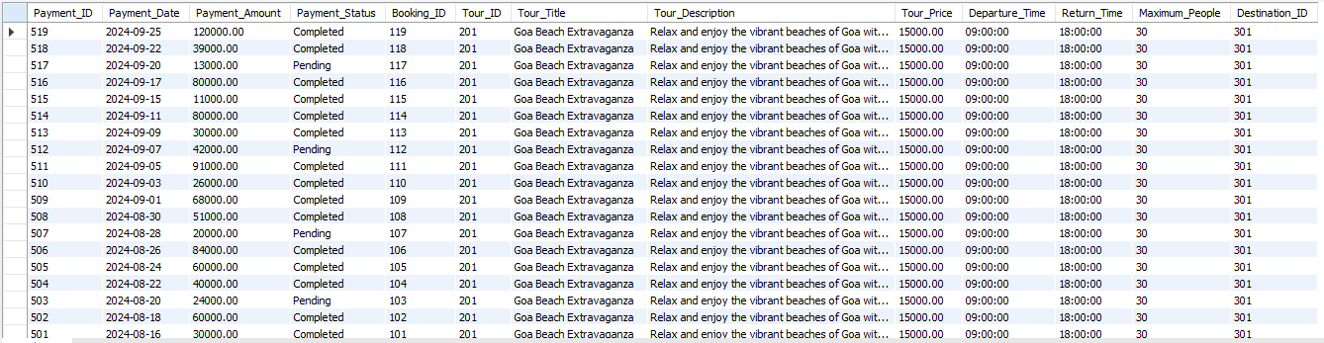

1. Inner Joins

ON clause :-

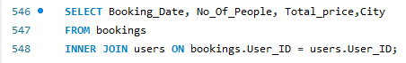

**Output :-**

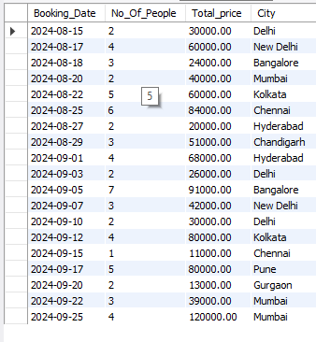

**Where clause :-**

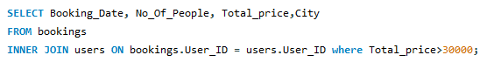

**Output :-**

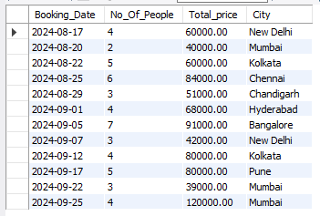

1. **Natural Joins :-**



**Output :-**

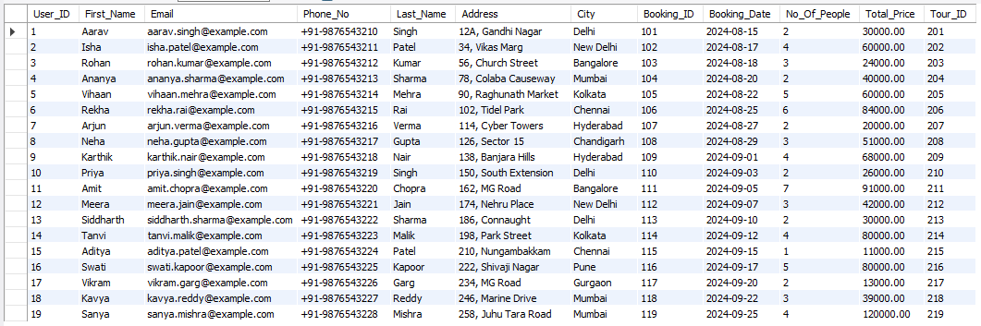

1. **Outer joins**
2. **Left joins :-**

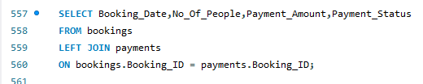

**Output :-**

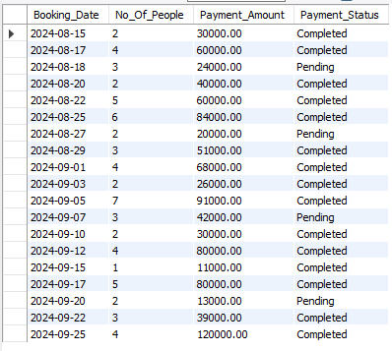

1. **Right joins :-**

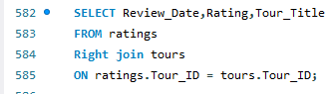

**Output :-**

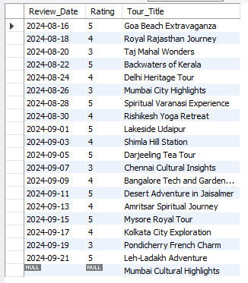

**Views**

**view is a virtual table created by a query that combines data from one or more tables.**

1. Simple View :-

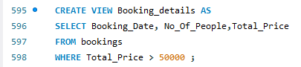

**Output :-**

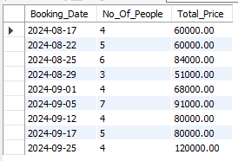

1. Complex View :-

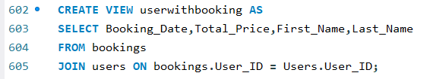

**Output :-**

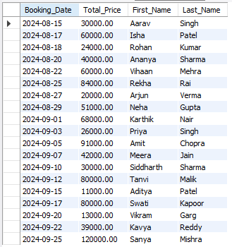

**Cursor**

a **cursor** is a database object used to retrieve, manipulate, and navigate through a result set one row at a time.

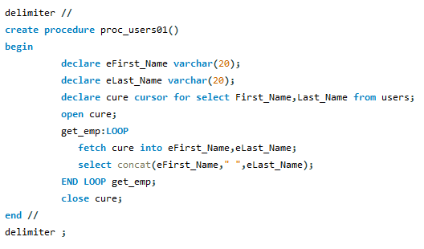

Call cursor :-



**Output :-**

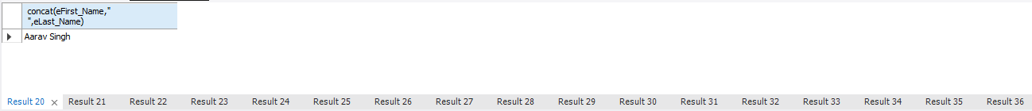

**Store Procedure**

**A stored procedure in SQL is a saved set of SQL commands that you can run as a single operation.**

Call :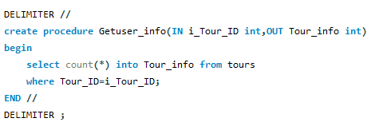

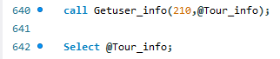

**Output :-**



**Triggers**

**A trigger in SQL is a special type of stored procedure that automatically executes in response to certain events on a table, such as insertions, updates, or deletions.**

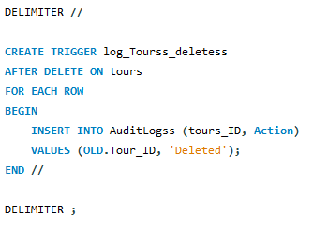

**Run :-**



**Output:**

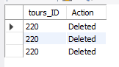

END